ART5: Building and Calibrating a Photometer

Introduction
Many research groups in the department make use of sensors to measure things in chemistry in an automated fashion. This is especially common within groups in Atmospheric Chemistry at York, who use a wide variety of sensors to measure temperature, concentrations of gases, humidity, particulate concentrations and similar parameters. Sensors also make up most of the commercial instrumentation you will have encountered, such as spectroscopic techniques, pH or conductivity meters and electrochemical probes. In this practical, you will build a single-wavelength photometer, learning about how a UV-Vis spectrometer works, and how sensors are used in chemistry.
Pretty much all sensors, ultimately result in providing a voltage output, which is how we measure the variation. This may be directly a voltage output from the sensor, or we may first convert a related unit into a voltage. In this photometer, we will be using a photodiode. When light (photons) react the photodiode, this generates a current, and it is normal practice to then convert this current (and in the process amplifying it) into a voltage which we can measure.
The generated voltage can easily be measured using a voltmeter (often as part of a multimeter), which is what you will use here. However, it is a relatively easy step to input a voltage into a data acquisition device (DAQ) in order to connect the sensor (or multiple sensors) to a computer to allow for automated measurement. These measurements could be very fast, maybe making many measurements over a millisecond timescale (for example to measure stopped-flow kinetics), or over a prolonged period (e.g. every minute over a year for climate recording).
Most instruments also require calibration to give meaning to the data which is being recorded. For instance, a thermocouple would provide a change in the measured voltage with changing temperature, but it needs to have voltages measured at known temperatures to provide calibration, much in the same way as the markings on a glass spirit thermometer are applied. For the photometer you will produce, you will calibrate your photometer using solutions of known concentration and measuring the output voltage. This will allow you to plot a calibration graph, demonstrate the Beer-Lambert Law, and measure the concentration of an unknown solution.

Risk assessment
Chemical | Hazard | Hazard symbol
Lead-free  solder | H333 May be harmful if inhaled.  H335 May cause respiratory irritation. | 
Potassium permanganate solutions (<0.02 M) | H411 Toxic to aquatic life with long lasting  effects. | 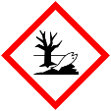
Sodium hydroxide solution  (0.2 mol dm⁻³)  [1310-73-2] | H290 May be corrosive to metals.  H314 Causes severe skin burns and eye damage. | 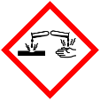
Aqueous New Fuchsin solution  (4.5 × 10⁻⁵ mol dm⁻³)  [3248-91-7] | H315 Causes skin irritation.  H319 Causes serious eye irritation.  H335 May cause respiratory irritation.  H351 Suspected of causing cancer.  H410 Very toxic to aquatic life with long lasting effects. |   
Physical hazards | The soldering irons are extremely hot (>300 °C) and will burn flesh. Do not touch the tip of the iron, or any of the metal parts.
Waste disposal | A separate waste stream for potassium permanganate will be provided. Bits of electrical wires, components and bits of solder can be placed into the offensive waste bins.
Precautions | Wear lab coat and safety specs at all times.  Conduct all chemical manipulations in a fume hood to contain spillages. Only instrumentation work and weighing should be carried out elsewhere.  Avoid breathing any fumes generated during the soldering.  Wear gloves while handling chemicals.
Revision date | 2024-07-29

Definitions

Current
An electrical current is the flow of charge around a circuit. The charge is carried by electrons (e.g. in wires) or ions (e.g. in solutions). Current intensity, the rate of flow of charge, is represented using the symbol I and is measured in the SI unit of amperes (A). A helpful analogy can be to consider charge flowing through a circuit as analogous to water flowing through a pipe system. In this analogy, the electrical current is the same as the speed of the water flowing in the system.
There are two types of current flow:
Direct current: the current flows continuously from positive to negative around the circuit. This is given the symbol ⎓. For this experiment we will only be considering direct current.
Alternating current: the direction of current flow oscillates (alternates) continuously (e.g. mains wiring has an oscillation frequency of 50 Hz). This is given the symbol ~.

Voltage
Voltage (or potential difference) is the difference in energy between two points in a circuit. This might be the potential difference across the power supply, showing how much energy is available in the circuit, or it could be the potential difference across a circuit component which draws power. Strictly, these potential differences are expressed as voltage differences, ΔV, but this terminology is often contracted to V.
In the water system analogy the voltage can be considered as the pressure of water in the pipe, with a higher pressure giving more energy to the system.

Resistance
Components in an electric circuit exert some form of resistance as they convert some of the electrical energy in the circuit into a different form (usually light or heat). The symbol for resistance is R and it is measured in Ohms (Ω).
In the water system analogy, resistance can be considered as a constriction in the pipe. The energy available is reduced after the constriction (i.e. there is a drop in the voltage).

Ohm’s Law
Current, resistance and voltage often have a direct relationship between one another in many materials. If components obey this law they are called Ohmic materials. Most of the components you are using obey this relationship. The relationship is:
$$V=IR$$

Anode
In electrical circuitry, the anode is the positively charged terminal of a component or power source. It is usual when connecting wires to components that red wire is used to signify the anode. Electrons flow around the circuit to the anode (negative charge flows to the positive terminal).

Cathode
The reverse polarity to the anode. The cathode is the negative terminal of a component and is conventionally designated using black wire.

Beer Lambert Law
The absorbance (A) of a solution is related to the concentration (c), the absorption coefficient (ε) and the path length (l). For a given compound ε is constant and using cuvettes of a fixed size the path length is constant which allows the equation to be simplified:
$$A=εcl=kc$$
Where
$$k=εl$$
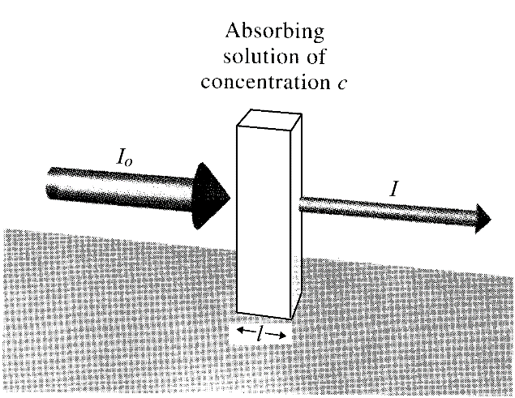
In a photometer, the difference in light intensity between the background (I₀) and the sample (I) are recorded (cuvette of blank solution and cuvette of sample).
$$\frac{I}{I_{0}}=\frac{I_{sample}}{I_{water}}=\frac{V_{sample}}{V_{water}}$$
However, this assumes that the output from the circuit is 0 V when no light is present in the photometer, which may not be true. A correction to the equation which subtracts the voltage at zero light (V_{zero}) can be made to give an overall equation for transmission (T):
$$T=\frac{I}{I_{0}}=\frac{I_{sample}}{I_{water}}=\frac{V_{sample}{-V}_{zero}}{V_{water}{-V}_{zero}}$$
There is a logarithmic relationship between transmission and absorption:
$$A=-\log_{10}T=-\log_{10}\frac{I}{I_{0}}$$

Electronic components
Component | Symbol | Picture | Description
Diode | 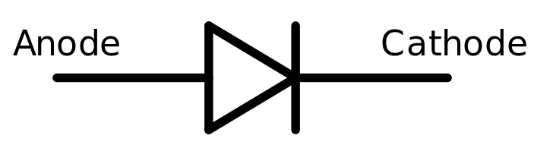 | 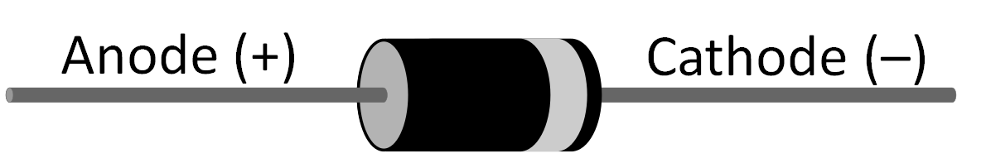 | A diode is a component that only allows current to flow in one direction. In the forward direction it has low resistance, but in the reverse direction very high resistance. Both LEDs and PDs are types of diodes.
Light emitting diode (LED) | 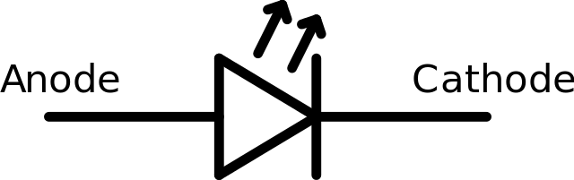 | 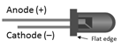 | A type of diode that also generates light when current is applied in the forward direction. LEDs are made from inorganic semi-conductors. For example the green LED used in this experiment is a Gallium(III) phosphide.
Photodiode (PD) | 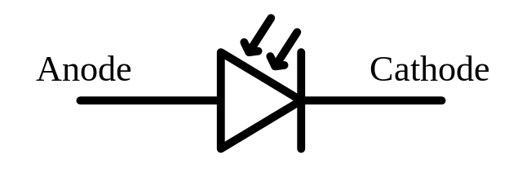 | 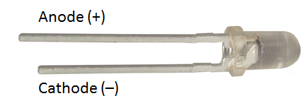 | This is a diode that converts light landing on the detector into a current. The detector is usually silicon based. The photodiode surface looks black when viewed from above.
Power source | 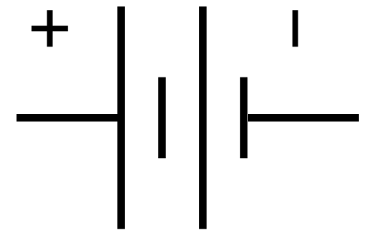 | 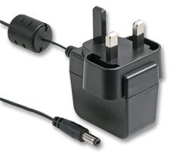 | A power supply unit (PSU) uses a transformer and other circuitry to convert the 230 V AC into a regulated 5 V DC supply. The PSU also limits the available current.
Resistor | 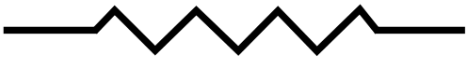 | 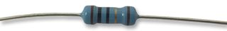 | A resistor is a device to limit current flow or lower voltages in a circuit. For example to drop the input voltage to the LED. Resistors are usually thin metal films which convert the electrical energy into heat.
Operational amplifier (Op Amp) | 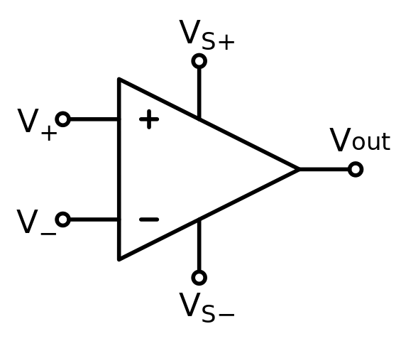 | 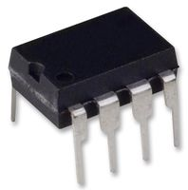 | An operational amplifier is a type of integrated circuit (IC) which amplifies the input. The Op Amp takes a current input and gives a voltage output proportional to the resistance placed across the Op Amp. Pin 8 requires 5 V, and pin 4 ground. Pin 2 and 3 take the input and pin 1 provides the output.
Capacitor | 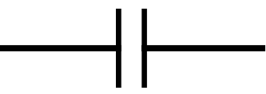 | 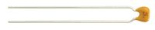 | A capacitor stores and releases charge. In this circuit it smooths the voltage output. The capacitors in this experiment are ceramic.
Wire | 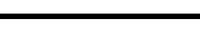 | 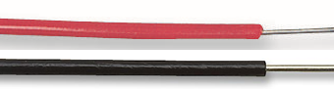 | Insulated copper wire. The coloured plastic coating is used conventionally with red designating the anode and black the cathode.

Photometer construction

Soldering workshop
Construction of the photometer will require use of soldering. The day will begin with a soldering demonstration, followed by plenty of time to practice. It is worthwhile taking your time with this workshop; the more practice you gain here is usually rewarded with a lower likelihood of photometer problems due to lose connections later on.
Once you think you have mastered soldering, check with a demonstrator that they are happy for you to proceed to construct the stripboard circuit.

Building the stripboard
The stripboard consists of rows of copper tape with gaps between. Anything connected by the tinned copper strips is electrically connected, but the individual rows are isolated from each other. Each row needs to be constructed so that there is a separate wire going to each leg of the two components. It is wise to follow the colour conventions for wiring. An example is shown below (the LED is depicted in green to aid identification). It is advisable to use quite long sections of wire (eg 30 cm) for each connection and label them.

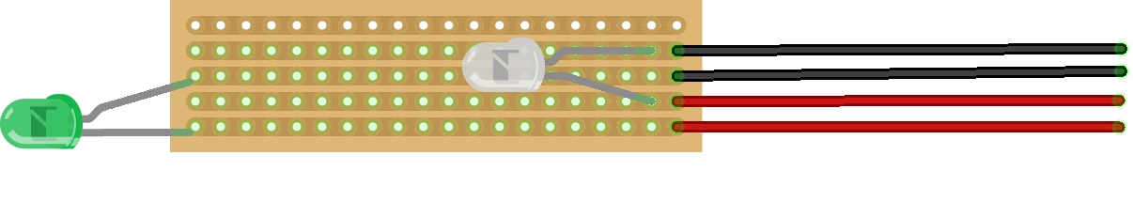
The photodiode and LED also need bending to face one another with enough space for a cuvette to fit between and the light to pass through the solution.
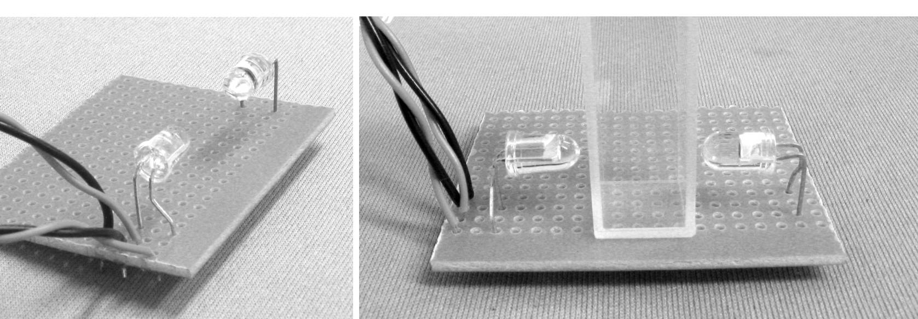

Constructing the circuit
Breadboards are used for rapid prototyping of circuits as it is easy to change components and doesn’t involve needing to solder/desolder each time. Breadboards consist of a large number of sockets where the sockets in each row are electrically connected, but are isolated from the other rows. The gap in the centre (between columns E and F) is also an insulator and allows integrated circuit chips to be used with the board.
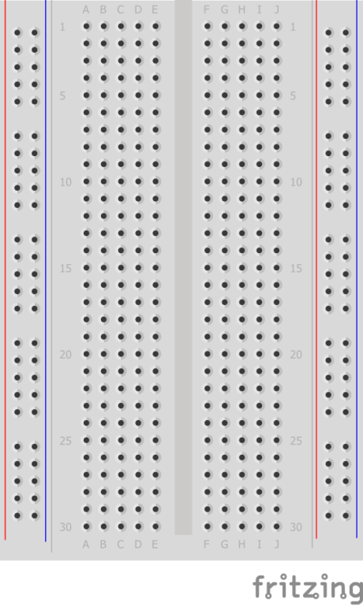
Construct the circuit according to the diagrams below (circuit diagram and example breadboard layout). Pay particular attention to the orientation of the operational amplifier (IC1), these are easily damaged if the voltage is reversed. The notch allows you to work out the orientation of the chip.
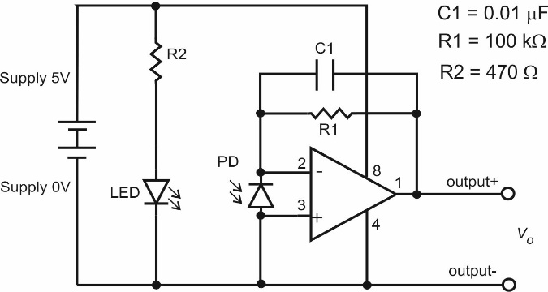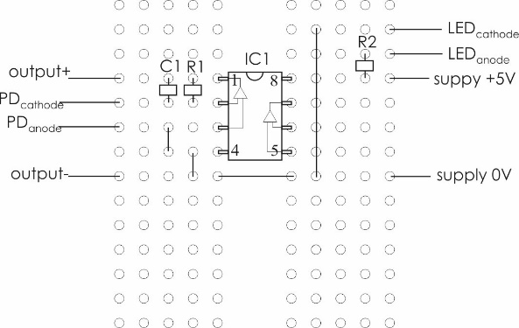
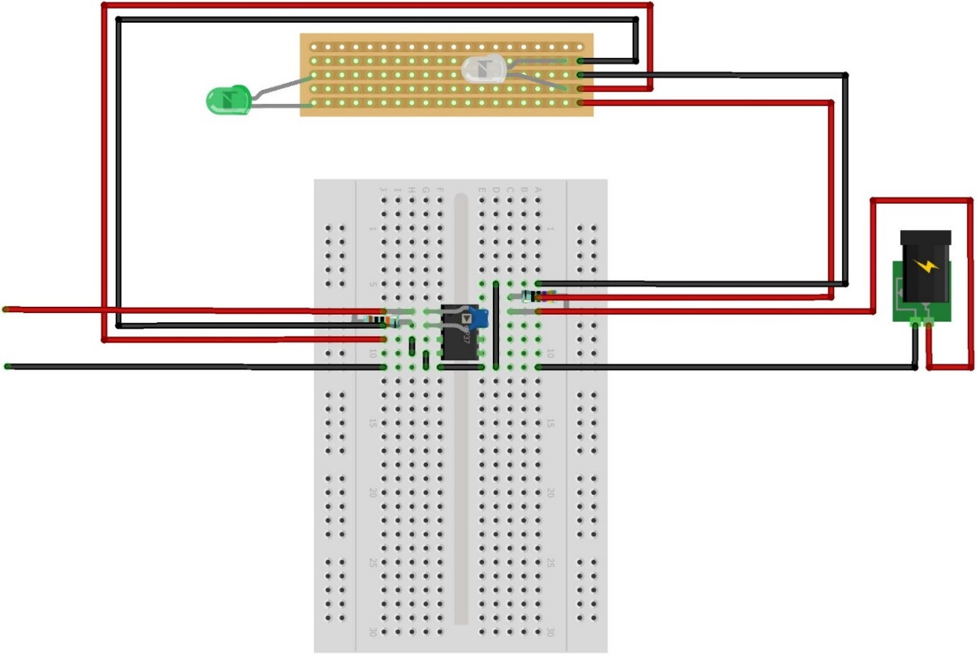
Different values of resistors are included in your packet of components. There are two ways to identify which resistor is which. In the appendices for this experiment there is a colour code chart for identifying resistor labelling and also information on using a multimeter to check resistor values.

Testing your photometer
Once you have constructed your circuit you will need to check that the LED turns on and that the photodiode gives a voltage reading which changes with light levels.
Next, you will need to construct an enclosure to protect your photometer from ambient light for when you are recording readings. Construct a cover (eg a box) that can exclude light from the stripboard section of your photometer. These can be constructed from the black card in the lab.

Calibrating your photometer
As with commercially available spectrometers, your photometer will only work successfully within its limits of detection. The operational amplifier in your circuit receives a 5 V reference voltage which makes its limits of detection between 0 and 5 V. If your photometer is reading (or is close to 5 V), then it is at its limit of detection and will need adjusting to ensure that it remains on scale. Your reading for a cuvette of water wants to be in the 2-4 V range. There are two ways to adjust your photometer and you should be aware of both methods, although the first method is the one you should utilise in this experiment.
- Changing the amount of light from the light source. If there is too much light landing on the detector, the resistor to the LED can be changed to increase the resistance, reducing the current to the LED. It is also important that the LED and PD are aligned to face each other, so that the light from the LED lands on the detector.
- Changing the gain (amplification) at the detector. The operational amplifier converts the current from the photodiode into a voltage by multiplying the current by the resistor across pins 1 and 2. Increasing the resistor will increase the gain of the circuit. It is important to be aware that changing the sensitivity will increase both the signal and the noise.

Calculating the molar absorption coefficient
In order to determine the molar absorption coefficient for potassium permanganate, the following concentrations of potassium permanganate solution are provided in the lab:
KMnO₄ / mM: 0.40, 0.35, 0.30, 0.25, 0.20
Using these solutions, you should then record the voltage on your photometer for each concentration, along with the voltage for a blank solution (water) and a dark voltage (unplug wire to the LED temporarily). Using these values, calculate the absorbance for each solution on your photometer, and determine the molar absorption coefficient.

Connecting to a computer

Data acquisition devices (DAQs)
At this stage, you have managed to build a working photometer, where we take measurements by reading the voltage using a multimeter. In order for a computer to ‘read’ these voltages, we make use of an ‘Analogue to Digital Converter’ (ADC or A2D) which converts the voltage into a number which is supplied to the computer.
There are many Data Acquisition Devices available which carry out this analogue to digital conversion of voltage using A2D converters. Different DAQs have varying numbers of ADCs available on the DAQ allowing multiple voltage sources to be read at the same time), as well as varying resolution (the level of voltage difference which can be differentiated), sampling rates (how quickly voltages changes can be measured) and voltage inputs (range of voltages to be measured). The prices of devices vary depending on these specifications from a few pounds to many thousands for a device.
In this practical we will be using a low-cost Arduino Uno board. This provides six A2D converters, which operate at 10-bit resolution with a theoretical sampling rate of 10 kHz for voltages in the 0-5 V range.

Resolution
Resolution for ADCs is usually described as a number of bits, eg in the case of the Arduino Uno, these are 10-bit converters. This means that the voltage range (0 – 5 V) gets split into 2¹⁰ divisions (2¹⁰ = 1024), which means that voltages differences of approximately 0.005 V can be resolved (5 ÷ 1024), which is roughly the same resolution as the multimeter used in this practical. The voltage is converted into the corresponding numerical value which is what a computer can interpret, these values ranging from 0 (= 0 V) and 1023 (= 5 V).

Arduino Uno board
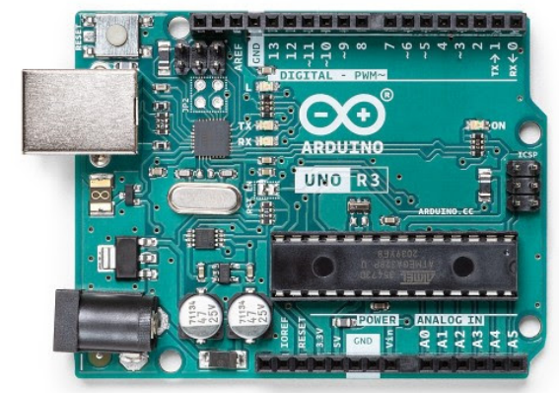
The Arduno Uno board is a microcontroller, which combines an integrated circuit with some computer processing capabilities enabling user written programming code to be executed on the board. The device has a USB interface which provides power to the board from the PC and allows a two way data connection between the PC and Arduino. The black pins on the board allow wires to be inserted to make electrical connections between circuits and the Arduino board. There are three main types of pins used on this board:
- Analogue-in pins
These allow connections of analogue voltages to the Arduino’s analogue to digital converters. We will use one of these pins (numbered A0) to connect our photometer’s signal to the board.
- Digital pins
These pins can be configured to either read an input, or to send an output. As digital pins these can be either on or off, corresponding to the presence (high) or absence (low) of a voltage. As an input this might be to read whether a switch is on or off, or as an output this might be to turn an LED on or off. Despite their abilities, these pins will not be used in this practical.
- Power pins
There are a couple of pins which provide power and ground connections on the board, including 5 V, 3.3 V supplies, plus ground (0 V). Whilst these are only capable of supplying limited currents, they are more than sufficient to power our photometer circuit.

Connecting your photometer to the Arduino
Please take care with connecting your photometer to the Arduino. It is possible to irreversibly damage the device if connections are made incorrectly.
There are two parts of the photometer to transfer over to the photometer:
- Removing the external power supply and powering the circuit from the power supply on the Arduino.
- Removing the multimeter and connecting the voltage signal to the Arduino.
Each connection will need to be made using a length of wire which has been stripped of the insulation at the end and insert the wire into the relevant socket on the Arduino. Each socket is labelled on to indicate its function.
To transfer the 5 V and ground supply, lengths of wire should be run between the Arduino 5V pin to the breadboard supply +5 V and from one of the GND (ground) pins of the Arduino to the breadboard supply 0 V, replacing the external power supply. The LED on the photometer stripboard should illuminate when the connection is made.
For the voltmeter, only the output+ wire needs connecting to the Arduino. The output– could be connected to a ground pin, but the Arduino is already aware of the ground supply, as it is providing the power source to the circuit, so a second connection is unnecessary. The output+ should be connected to pin A0.
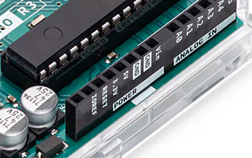

Arduino code
The Arduino microcontroller runs a small amount of code to instruct the device with the tasks it needs to undertake. Arduino code is written in using a language derived from C, which uses a different syntax to the Python code used in the rest of the practical. The code deployed to the Arduino has been made available alongside the Python scripts you will use. Principally the code instructs the Arduino to read the voltage value on pin A0 every 100 ms and to stream the values via its serial interface. We will then read the serial stream from the computer using Python.

Check Python setup
Before running the scripts used for this practical, it is worth checking that you have a working python environment with all the required packages installed. In order for python to receive data from the Arduino the PySerial package will be used. You should download and run the test python script to check the python installation is correctly function, paying particular attention to the ‘serial’ package being present.
python test.py

Script
Download take_measurement.py which is the python script used to read and collect data from the Arduino. The script is executed along with a parameter which determines the data-collection mode to be used. There are three possible parameters (single, stream, collect) which will be used in the data collection process. First, we need to make some minor edits to the script.

Determining hardware interface
In order to be able to receive data from the Arduino, the hardware interface for the Arduino needs to be specified in each python script. Using python, we can generate a list of connected device interfaces and obtain a description of these devices. This can be achieved by running the command:
python -m serial.tools.list_ports -v
From the list, identify which COM port the Arduino is connected to, and you will need to appropriately set this in the script as the interface variable:
interface = 'COM1'

Read voltage values
Once the interface has been set in the script, we can run the script to test our setup:
python take_measurement.py single
This will instruct a single datapoint to be collected from the photometer setup and will return the 10-bit value.
Alternatively, we can see a live reporting of the 10-bit values by running the script in stream mode:
python take_measurement.py stream
You should see the values being displayed rapidly. This is the realtime list of measurements being received by the computer from the Arduino. Try varying the amount of light reaching the photodiode and see how the values vary. To escape the data stream press Ctrl+C.

Collect photometric data
Using the single datapoint recording mode, recollect your photometric data for the potassium permanganate solutions and calculate the molar absorption coefficient. You will need to collect a dark voltage reading (disconnect one of the LED wires from your breadboard) and a background measurement for water. The same relationship between absorbance, transmission and light intensity applies, only this time the measurements are expressed as a 10-bit number rather than as a voltage.

Record a kinetic run
With our photometer now connected to a computer, repetitive data collection becomes easy to achieve. A good test-case for this is to record a kinetic run, where the absorbance is changing as the reaction progresses. We will record a data set for the bleaching of new fuchsine dye (1.0 mL, 4.5 × 10⁻⁵ mol dm⁻³) in the presence of sodium hydroxide (2.0 mL, 0.2 mol dm⁻³) under pseudo-first order conditions:
python take_measurement.py collect
The variables for duration and interval will need to be set appropriately in the script. Record the data for 200 s recording a datapoint every second.
$$\frac{d\left[{Dye}^{+}\right]}{dt}=-k_{obs}[Dye]$$
$$k_{obs}= k[^{-}OH]$$

Appendix

Resistor values
Colour | 1st Band | 2nd Band | 3rd Band | Multiplier | Tolerance
Black | 0 | 0 | 0 | 1
Brown | 1 | 1 | 1 | 10 | 1%
Red | 2 | 2 | 2 | 10² | 2%
Orange | 3 | 3 | 3 | 10³
Yellow | 4 | 4 | 4 | 10⁴
Green | 5 | 5 | 5 | 10⁵ | 0.5%
Blue | 6 | 6 | 6 | 10⁶ | 0.25%
Purple | 7 | 7 | 7 | 10⁷ | 0.05%
Grey | 8 | 8 | 8
White | 9 | 9 | 9

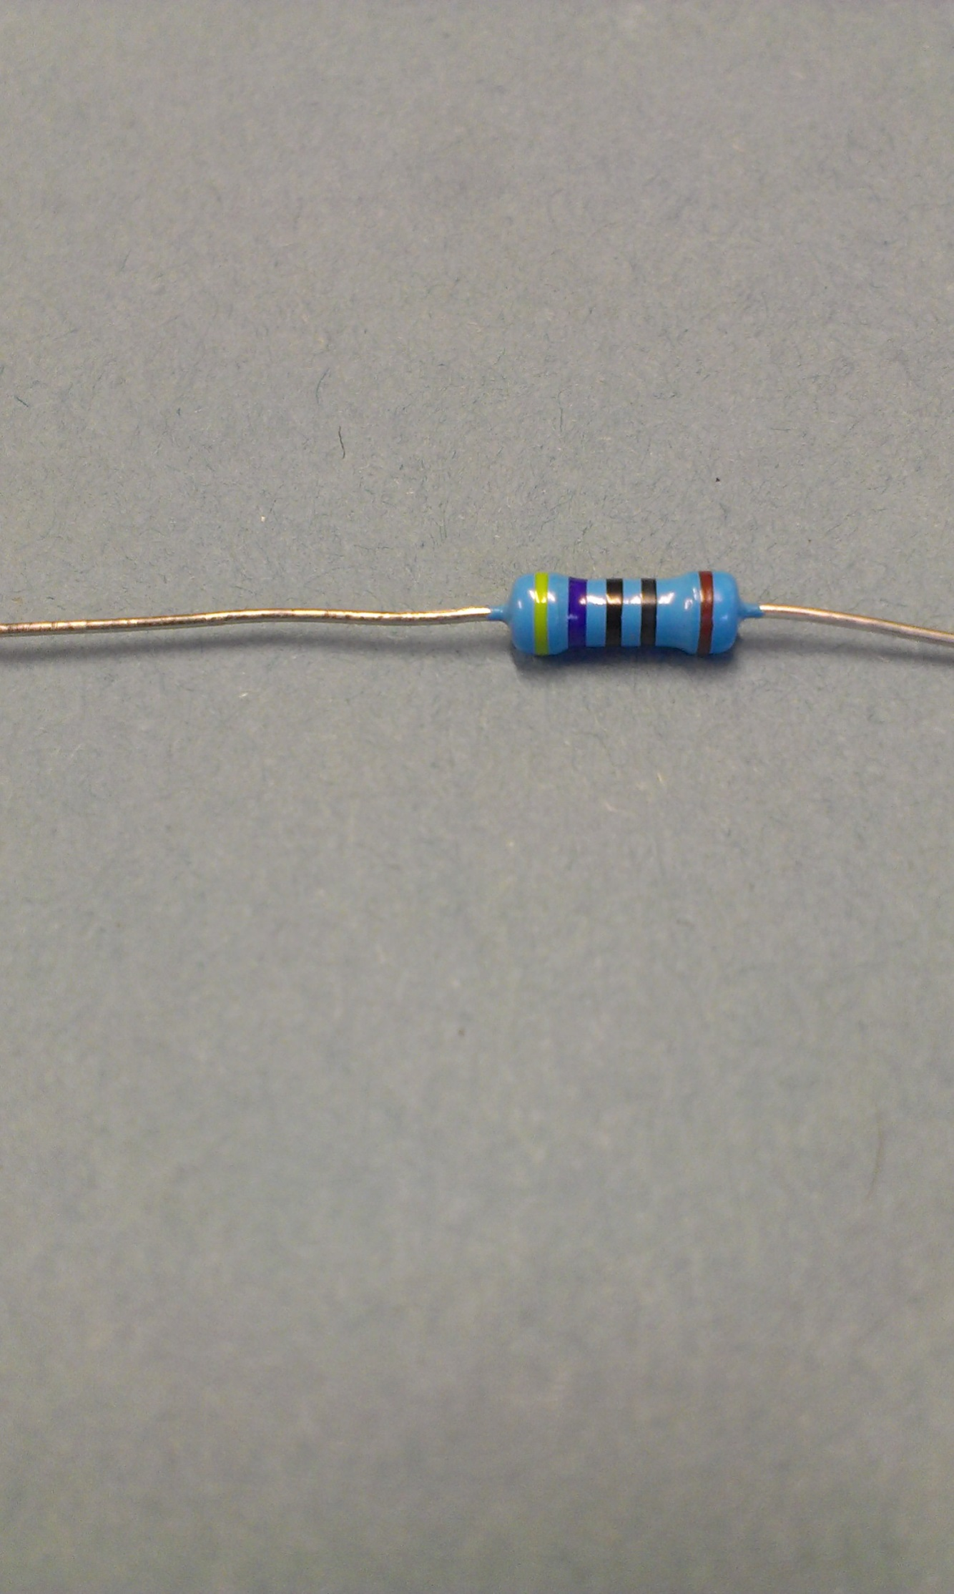
Resistors should be read left to right with the tolerance band on the right (identified by the wider gap – see photo, left)

Resistor combinations
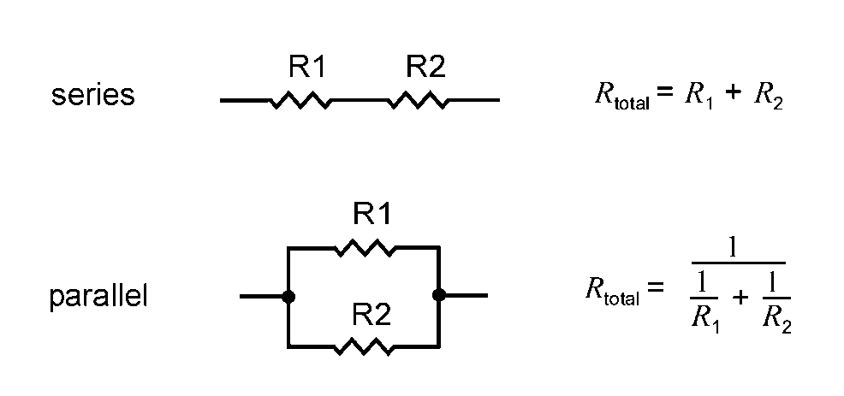

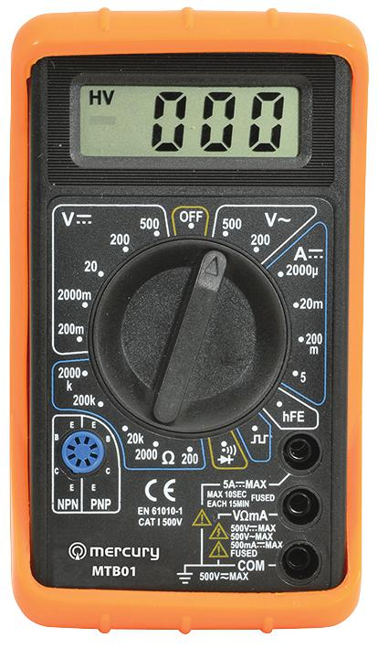
Using a multimeter
The multimeters you are supplied with a capable of measuring various parameters. In this experiment we are interested in measuring voltage and resistance. In order to set up the multimeter for use we need to attach the cables. The black cable goes in the common (ground, ) socket and the red cable into the Voltage/Resistance (V/Ω) socket.
The dial needs to be turned to what you want to measure. The numbers show the measurement limits for each category.

DC Voltage
We want to record DC voltage between 0 and 5 volts, so we would turn to the V⎓ 20 section. The voltage is then measured across the component of interest (eg try testing the power supply is 5 V).

Resistors
Resistor values can be measured using a multimeter. The multimeters you are supplied with can measure up to 2000 kΩ (or more correctly written as 2 MΩ). If you know what value you are expecting for a resistor, set the multimeter to the value higher (eg for a 100 kΩ resistor, set the meter to 200k) and the value will be displayed on the screen. For values with a k in the number, the displayed value is given in kΩ, for those without the k, the value is in Ω.
If you have an unknown resistor, set the multimeter to the highest resistance (2000k) and read the value. Change through the values until the meter displays sensible precision. If the meter is showing 000, the resistance is too small for that scale. If the meter is reading 1, the resistance is too high for the meter (eg a 10 MΩ resistor can’t be measured on these meters). You should find the value for your resistor is close to the value indicated by the coloured bands.

This is how current is described by convention, but is the opposite to the actual flow of electrons around a circuit.

